GLY 4310C

LAB 11 METAMORPHIC ROCKS, PART 3

CONTACT/REGIONAL AND METASOMATIC ROCKS

Marble, Quartzite, and Serpentinite

Serpentinite consists almost wholly of one or more serpentine minerals, which include antigorite, chrysotile, and lizardite. It may also include calcite, magnesite, dolomite, talc, chromite, magnetite, and other minerals. the color is usually green to greenish-black, although yellow and even reddish varieties are known. Luster varies from dull to waxy. They may be homogeneous or banded, streaked, or spotted. Polished serpentinite is often called serpentine marble.

Magnesite – 0% - 50%,

Slickensides visible on some specimens. Some specimens are schistose. Color varies from mottled dark green to black in some, in others light and dark green layers. Some exhibit magnetic pull due to magnetite and/or pyrrhotite.

For more information:

<http://www.alexstrekeisen.it/english/meta/serpentinite.php>

<https://www.youtube.com/watch?v=2LN9lMd1uHg>

**Sample 43. Serpentinite**

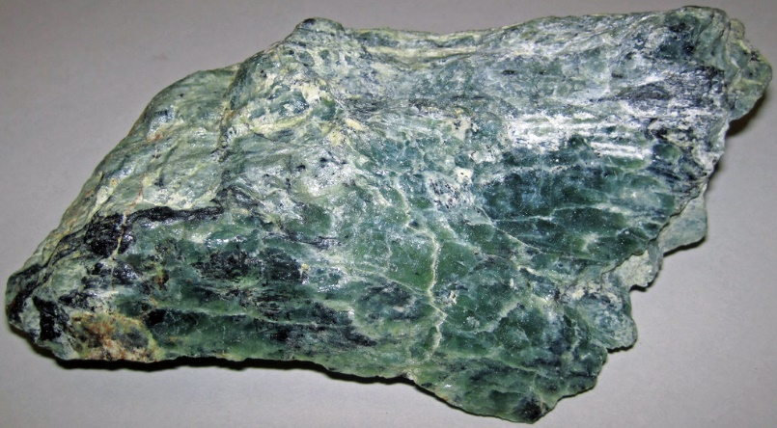

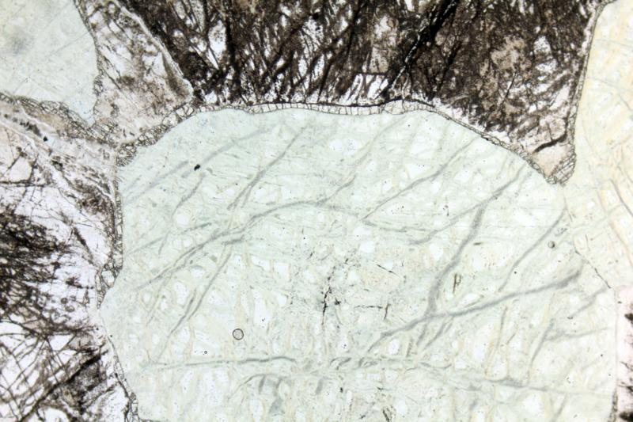

Rounded olivine (completaly altered by serpentine) and brown altered pyroxene. note the radial fractures, due to the increase in volume during the alteration of olivine in serpentine.PPL image, 2x (Field of view = 7mm)

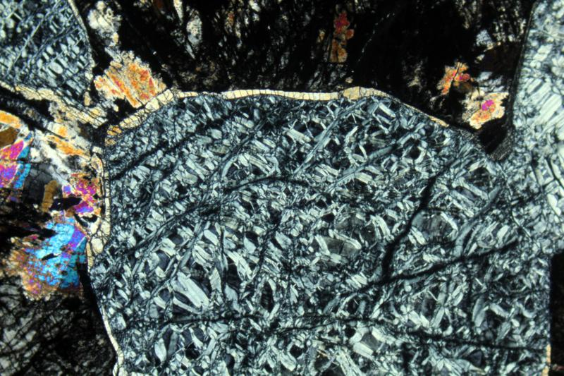

Rounded olivine (completaly altered by serpentine) and brown altered pyroxene. XPL image, 2x (Field of view = 7mm)

**Sample 72. Pink Marble**

Marble is a metamorphic rock consisting of fine to coarse-grained recrystallized calcite and/or dolomite. It is often formed by metamorphosis of limestone and may be either contact or regional metamorphic rock intermediate in grade between slate and mica schist. The surface may have a silky sheen which results from minute crystals of sericite, chlorite, etc. The calcite and dolomite crystals are very often twinned as the result of deformation. In calcite the twin planes are (1021) and in dolomite (022 1). Differentiation of calcite and dolomite may be done in thin section on the basis of the twinning. In calcite the twin lamellae are parallel to the long axis of the rhombohedron or are oblique to it, forming a non-rectangular grid. In hand specimen or thin section, staining of the limestone can be used to separate calcite from dolomite.

Calcite: 80%-90%

Biotite: 1%-5%

Granular, many specimens show banding of dark layers and pink calcite.

For more information:

<https://micro.magnet.fsu.edu/primer/techniques/polarized/gallery/pages/pinkmarblesmall.html>

Calcite mineral: <http://www.science.smith.edu/geosciences/petrology/petrography/calcite/calcite.html>

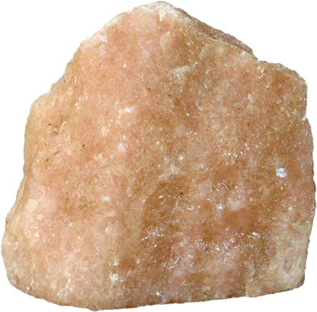

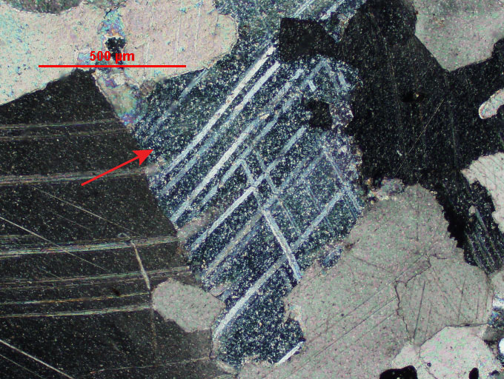

Photomicrograph of calcite under cross polarized light using 10X magnification. Note how the twins stand out against the extinct crystal and the crystal is speckled with 'birefringent dust'.

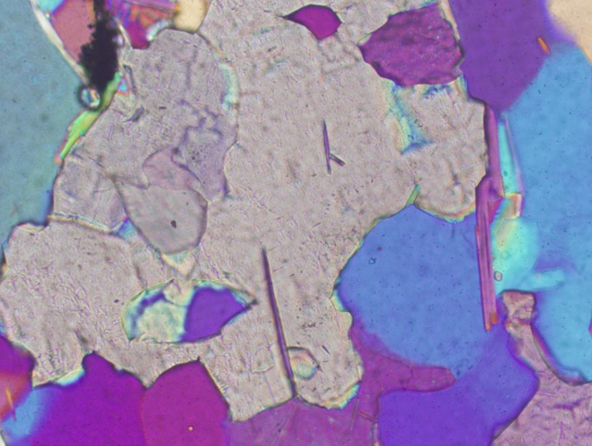

Photomicrograph of calcite at 20x. The pale, high order interference colors of calcite under crossed polar are evident

**Sample 73. Dolomite Marble**

Recrystallized dolomitic limestone producing interlocking grains of dolomite. Marble, both limestone and dolomitic, is an extremely variable rock in appearance since it depends on what rock was the parent, and the degree of metamorphism it underwent. It can be virtually any color from white to black to red to green, etc., and sometimes it will contain metamorphosed fossils or other components. The most definitive test for the rock would be acid (weak bubbling or bubbling only when powdered), and a hardness less than glass. In dolomite polysynthetic twinning appears parallel to the short and long axis of the rhombohedron, forming a rectangular grid.

Dolomite: 99%

Granular Few crystals of goethite (brown) on large sample. Phlogopite present in some

specimens.

For more information: <https://www.youtube.com/watch?v=cVwNowHpZ1s>

<https://www.youtube.com/watch?v=3yMHYsDoKf4>

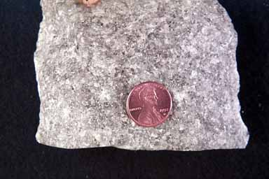

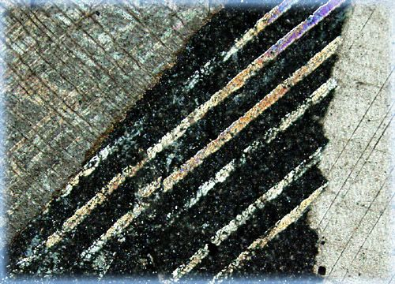

Twinning in dolomite crystal.

**Sample 76. Quartzite**

Quartzite may be regional or contact metamorphic. It may occur as the result of

metamorphism of quartz sandstones (psammitic rocks). Other quartz-rich sedimentary rocks (quartz conglomerate, chert) may also be metamorphosed. The quartz from argillaceous sandstones may be relatively undeformed by stress induced changes. In the argillaceous rocks stress is largely absorbed by the clay particles and the quartz particles may rotate without shearing. They may show strain and generally have sutured (interlocking) contacts.

Quartz: 100%

Purple to pinkish aphanitic rock. Color due to small impurities.

For more information: <https://www.alexstrekeisen.it/english/meta/quartzite.php>

<https://www.youtube.com/watch?v=0k-fYy8gQ8E>

<https://www.youtube.com/watch?v=gfIScywmjvM>

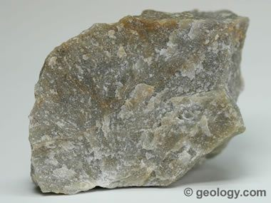

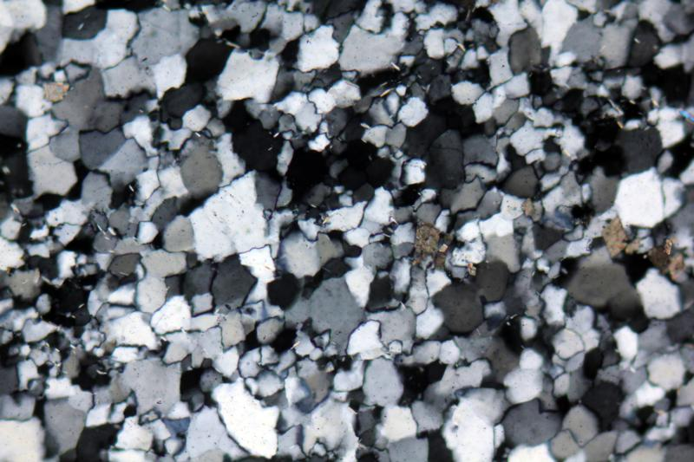

Quartz crystals in a Quartzite. XPL image, 2x (Field of view = 7mm)

**Sample 85. Staurolite Quartzite**

Staurolite is a neosilicate mineral that is generally reddish-brown to black in color. Common in metamorphic rocks, such as quartzite, staurolite often forms in such a way that its prismatic crystals are twinned, giving them the appearance of a cross.

Quartz: 75%

Magnetite: 0-5%

For more information:

<https://www.alexstrekeisen.it/english/meta/eclogite.php>

<https://www.youtube.com/watch?v=9DsNK7IMhvI>

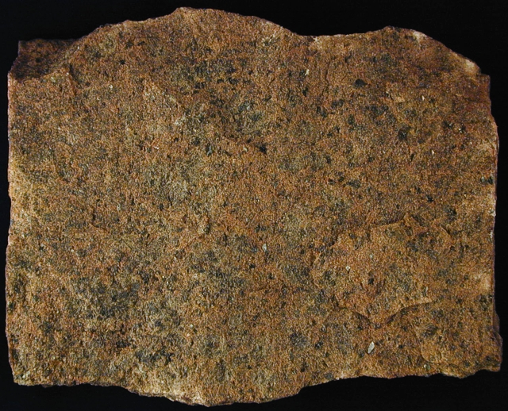

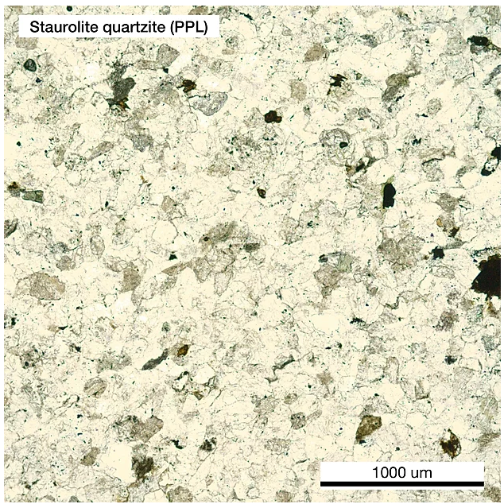

It usually shows no cleavage and colourless under PPL, but it shows first order grey to white interference colour. Small portion of staurolite disseminate in the sample, showing brownish yellow under PPL and first order yellow to orange interference colour. Those minerals can have anhedral shape and positive high relief. Meanwhile, there is no cleavage within staurolite. Few amounts of black hematite or magnetite can be found in the sample.

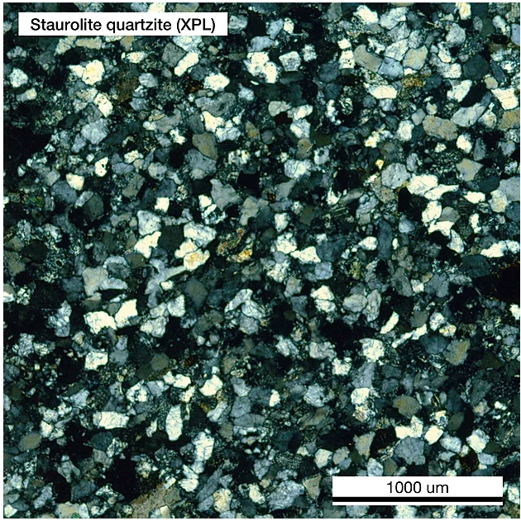

Staurolite quartzite in XPL

**Sample 86. Kyanite Quartzite**

**Kyanite Quartzite** Sometimes alternatively referred to as disthene, kyanite appears as long, bladelike crystals that range from white to gray, black, or blue in color. The azure shades of some samples can be quite beautiful, and, in fact, the mineral’s most commonly utilized name stems from the Greek word ***kyanos***, meaning "blue."

Quartz: 20-65%

Kyanite: 30-80%

Magnetite: 0-2%

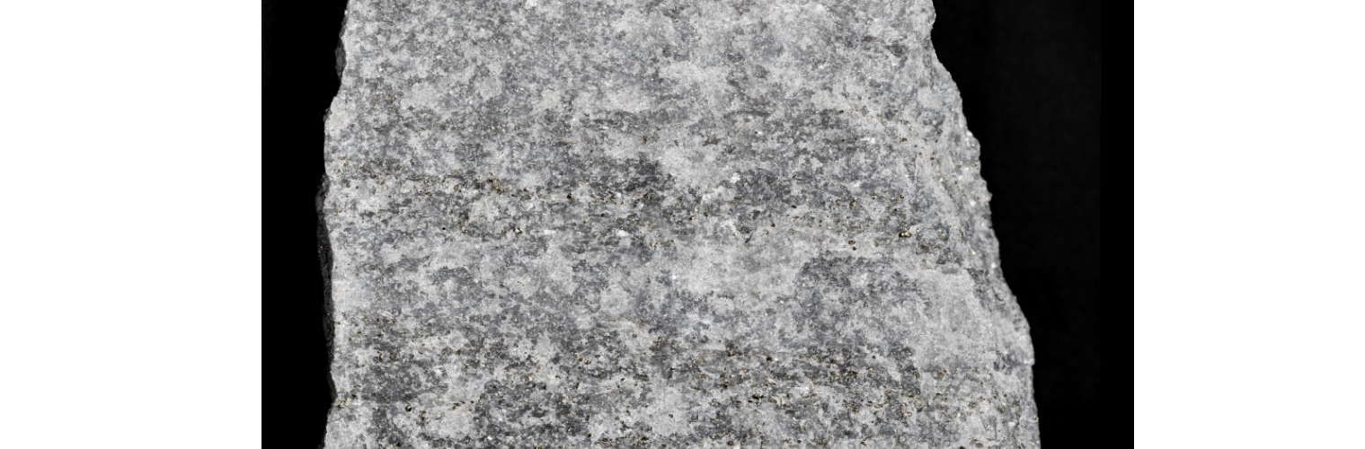

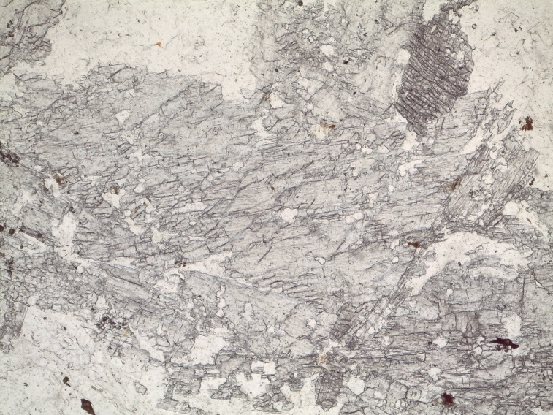

Kyanite in PPL

<https://www.youtube.com/watch?time_continue=1&v=aOsD_lRYWuc&feature=emb_logo>

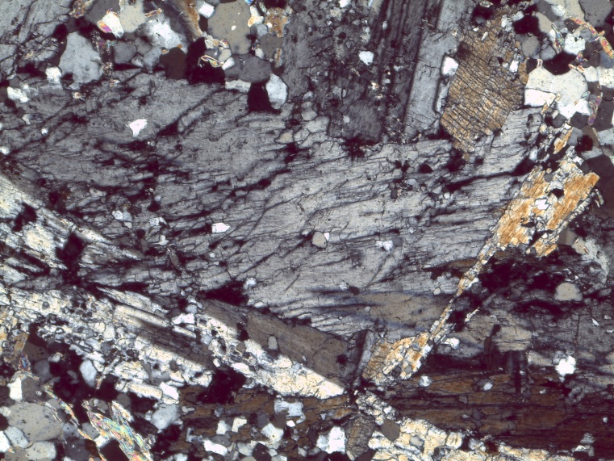

Kyanite in XPL

<https://www.youtube.com/watch?time_continue=2&v=H4jcL7exIOI&feature=emb_logo>